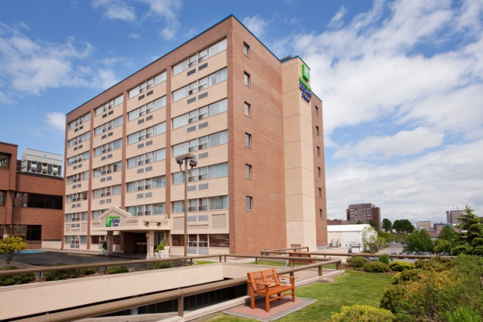

Holiday Inn Express & Suites Saint John Harbour Side
400 Main Street And Chesley Drive St. John, New Brunswick E2K4N5 Canada
1-506-642-2622
- Reference - Kingston Blue Marlins
- 109.00 + taxes per night
- 2 queen beds in each room
- Complimentary Breakfast
- Complimentary high speed internet
- Fridge and microwave in every room
- Indoor pool and whirlpool
- Free parking
- Fitness centre
- Cutoff date is June 12,2015

